“Swachhata Pakhwada
2018- Swachhata se Sidhhi”

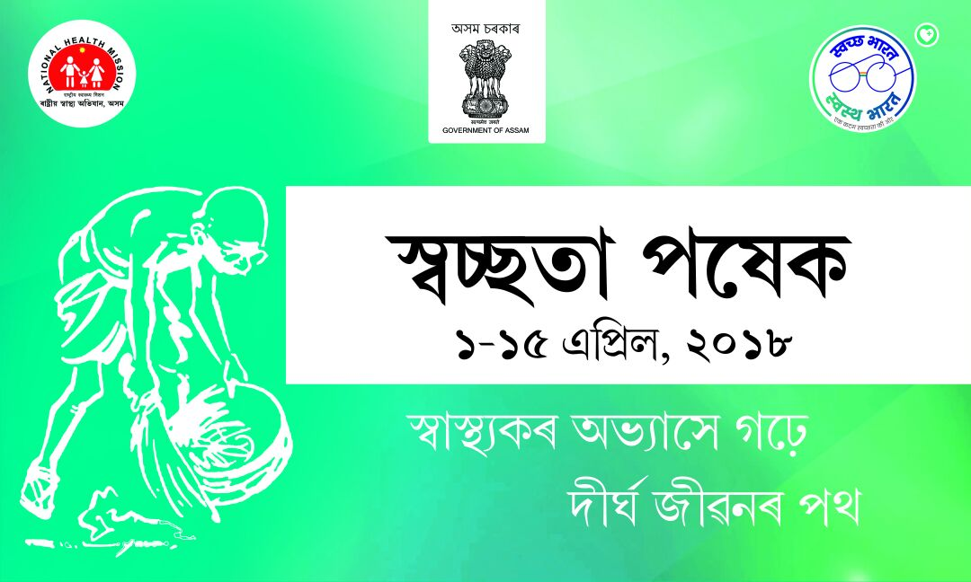
State Quality Improvement Division,
National Health Mission
Assam
Implementation of the Swachhta Pakhwada

- INAUGRATION: Swachhta Pakhwada was inaugurated by Mission Director NHM Assam. And following nodal officer were designated at the State Level to look overall activity (SPM, State Media Expert and Program Executive (Quality)). At District Level Nodal officer were Joint Director with coordination with DPM and DME. Around 4131100 lakhs swatchhta pledge were taken on 1st April. Signature campaign was done during this event.

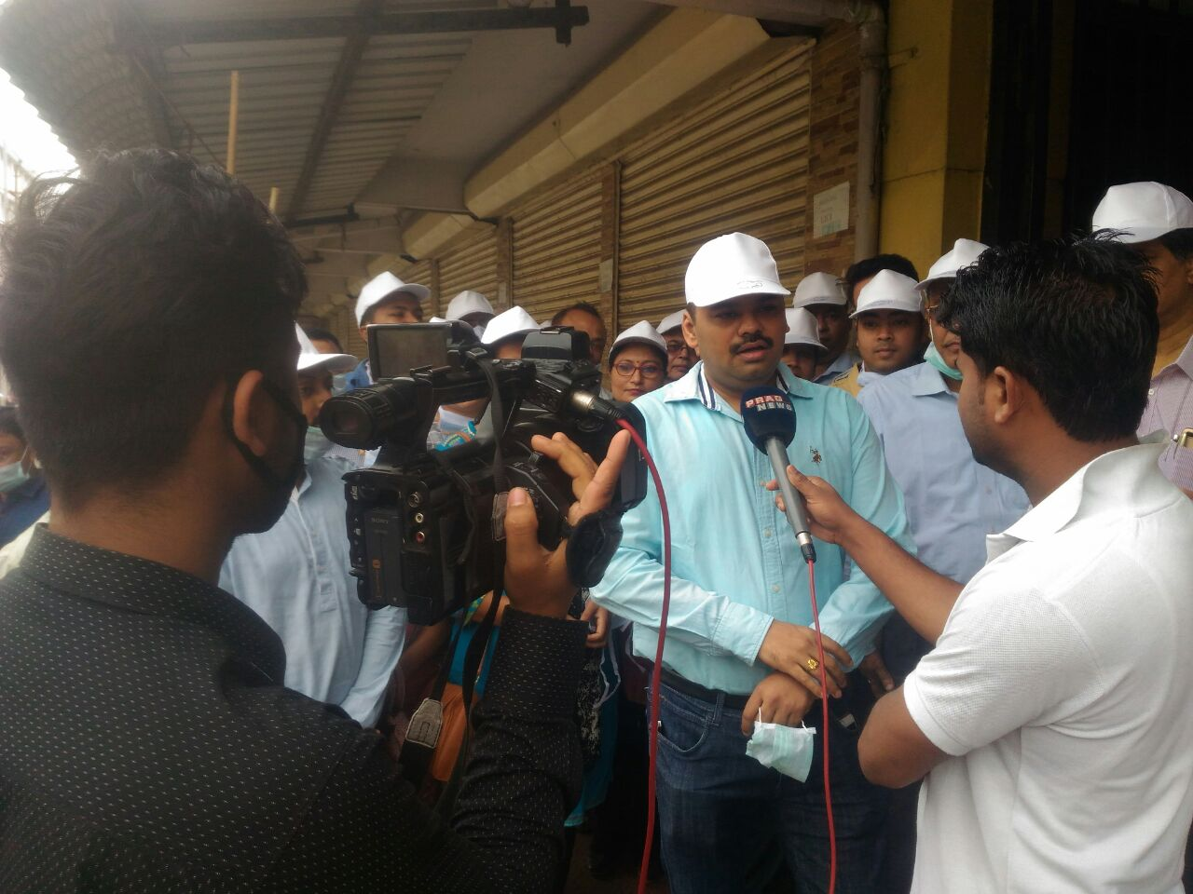
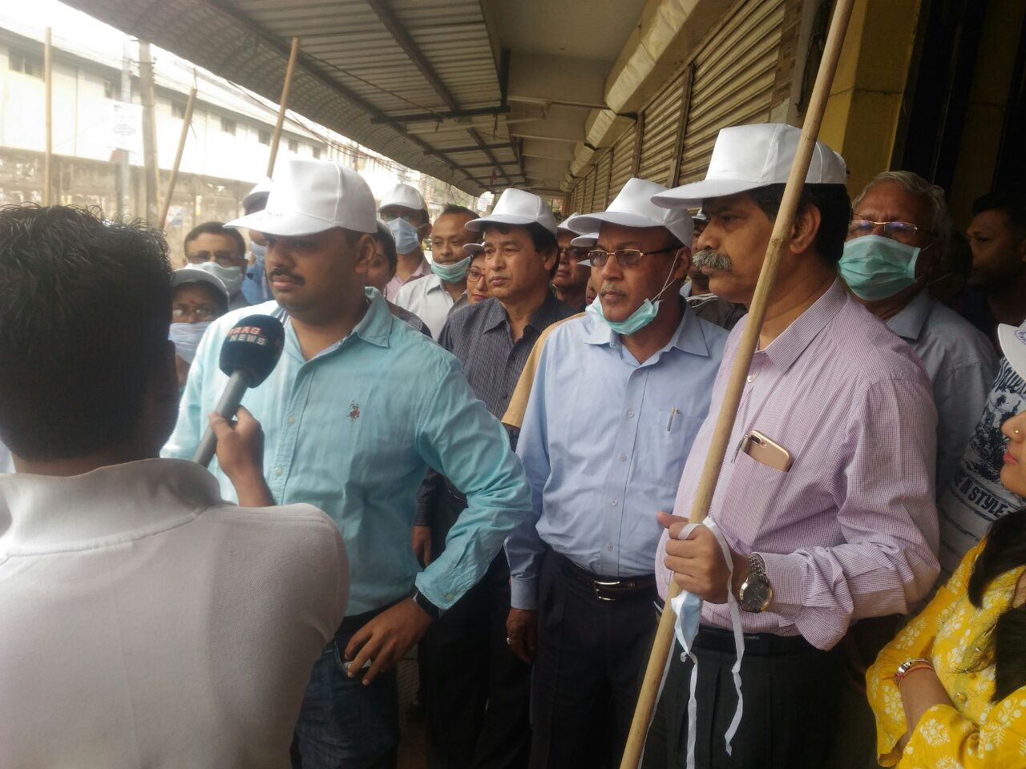

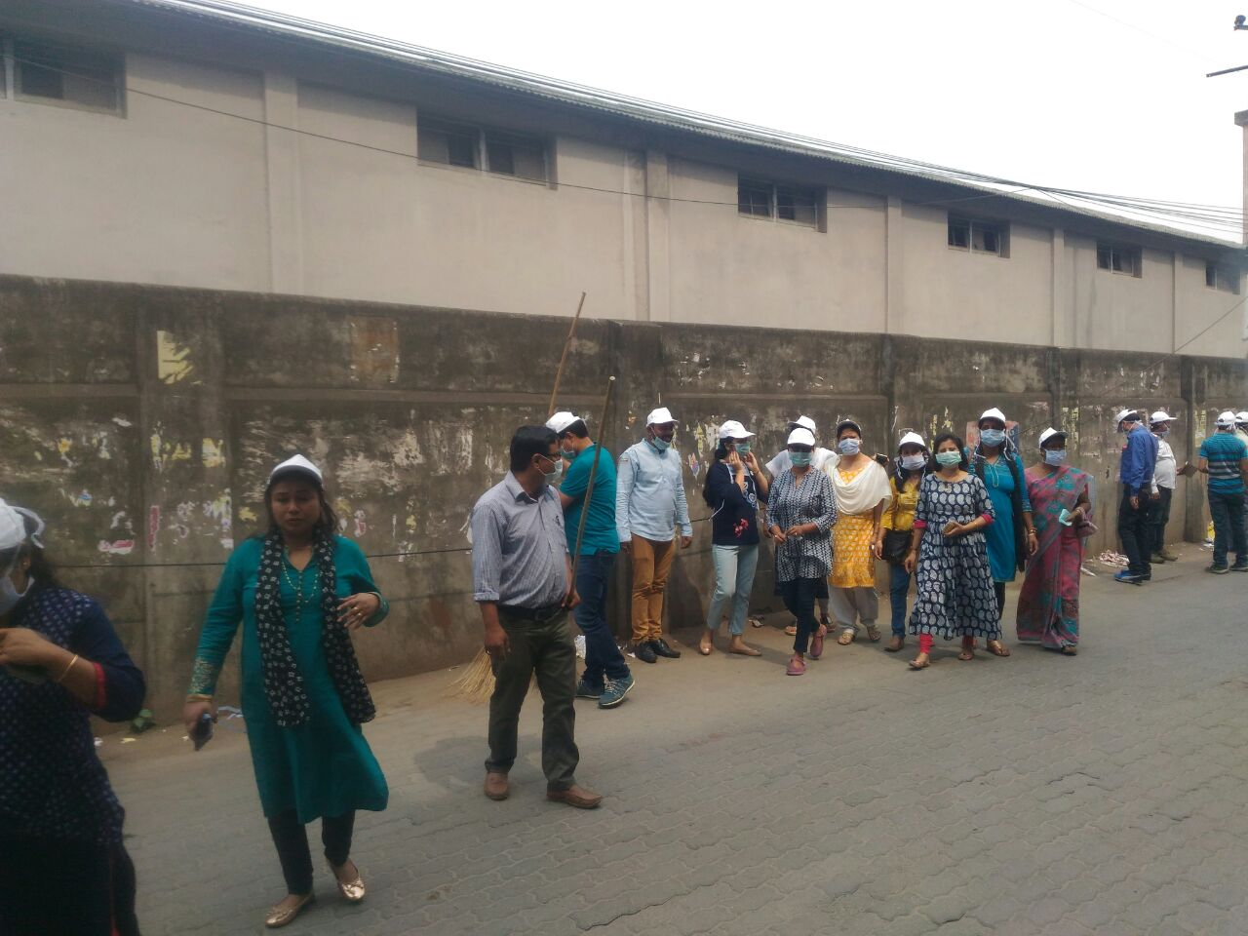

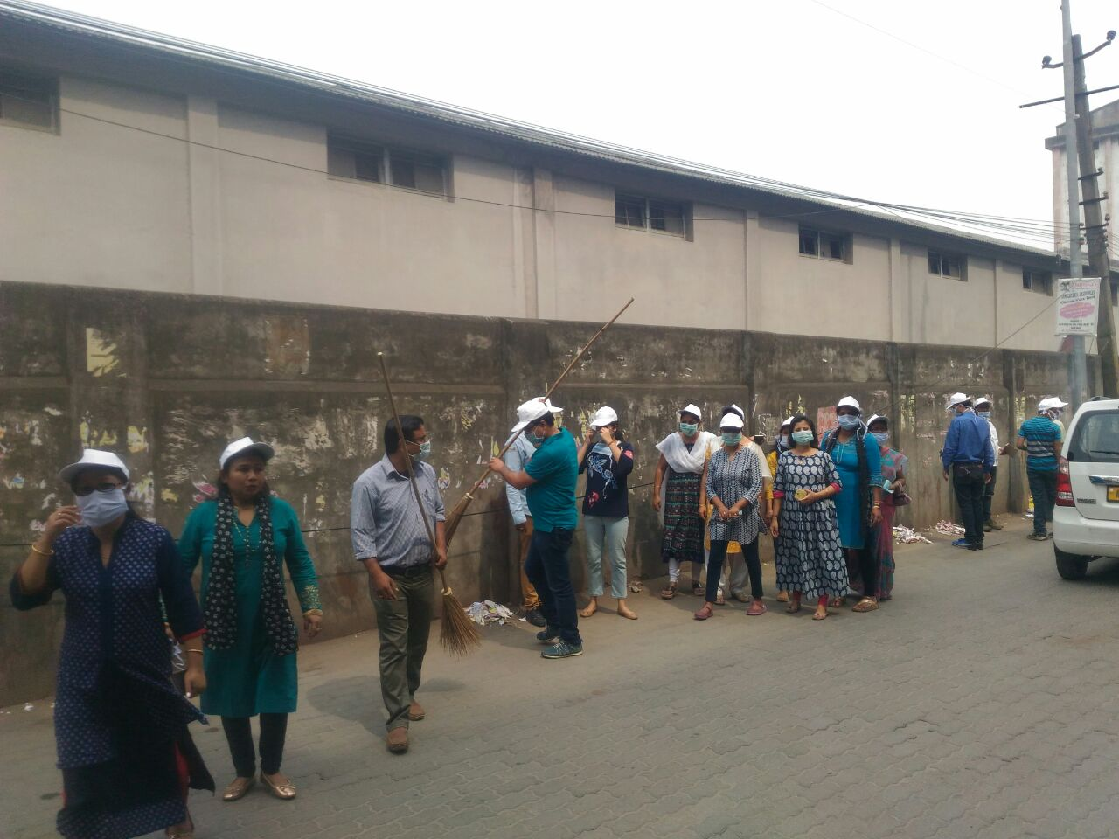

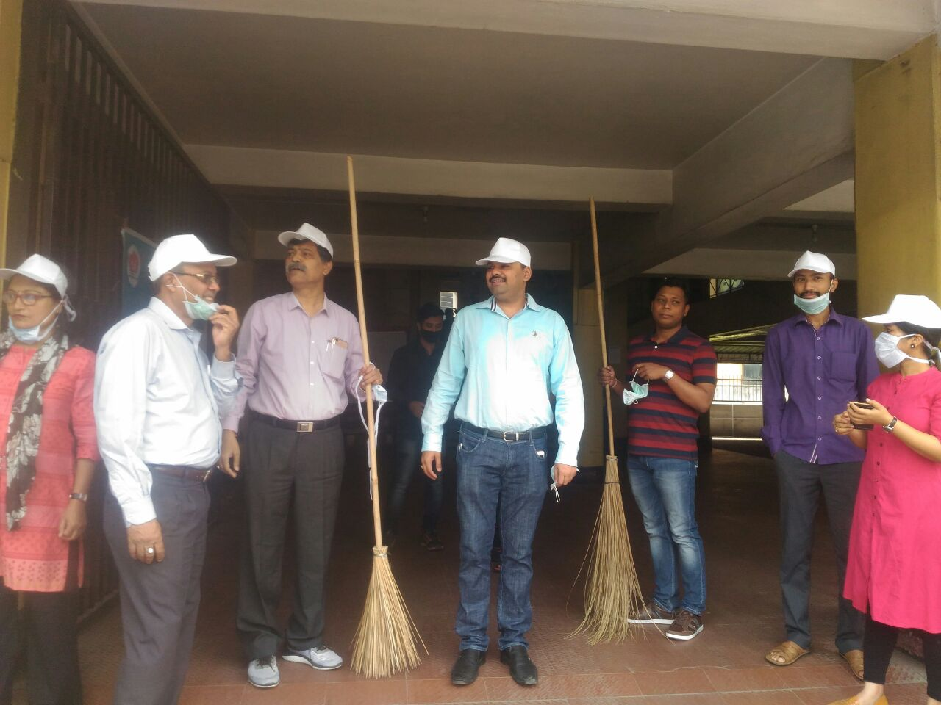

- 27096 number of individuals were involved in Shramdan. There was good involvement of army personnel’s in the shramdan activities along with health staff, MPs, MLAs and celebrities. During this campaign awareness activities had done in 1209 facilities of Assam.

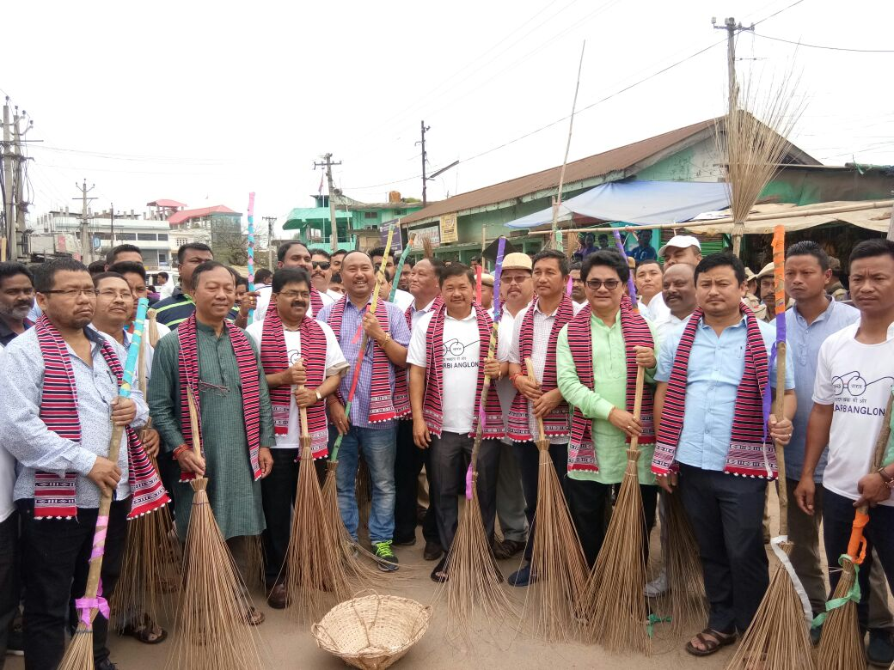

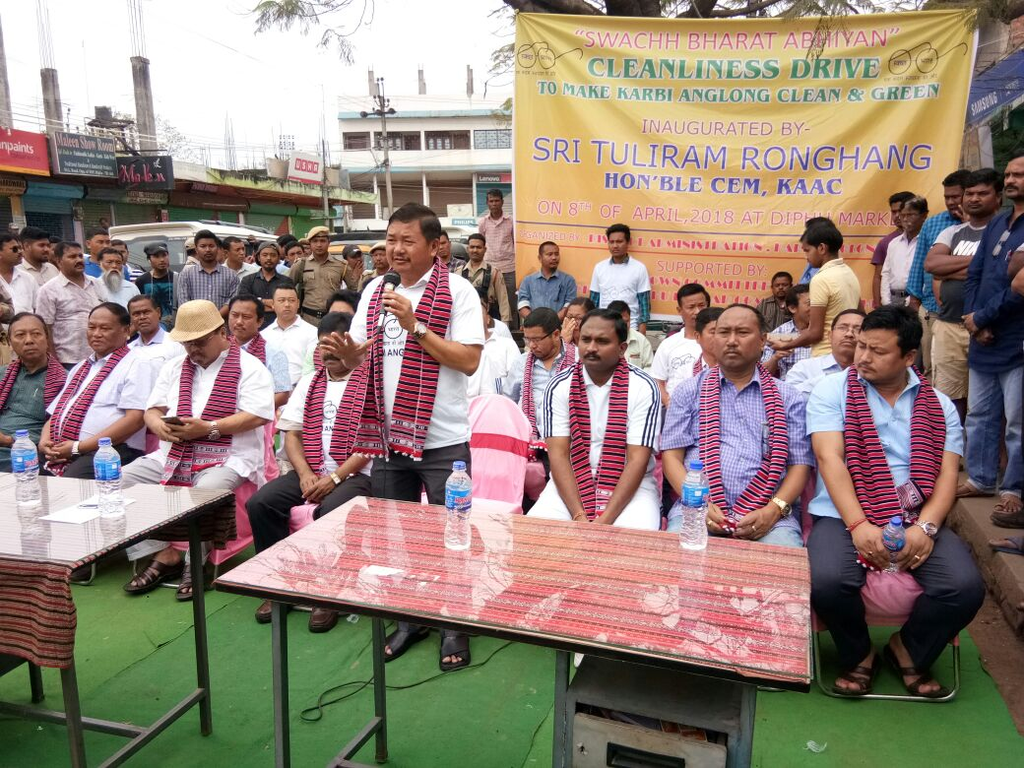

- 7th April : World Health day was celebrated in Assam in 1209 Health Facility. 4212 numbers of health staff were immunized on Hepatitis B.

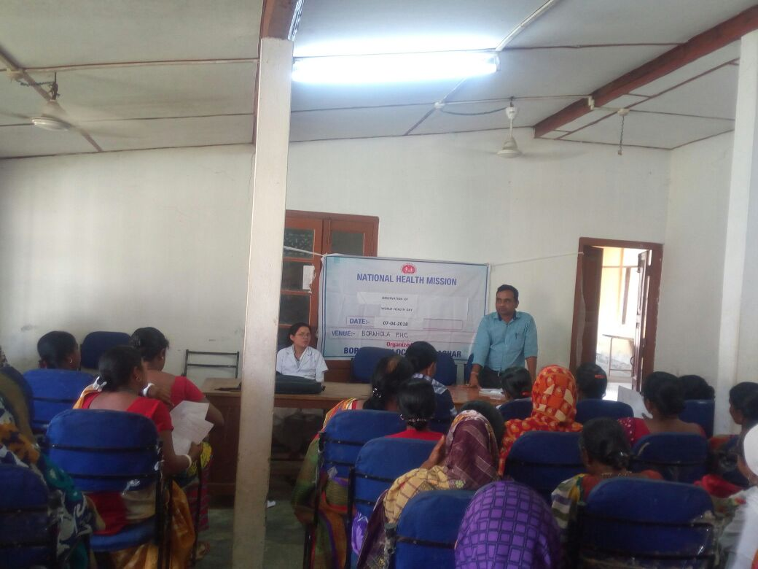

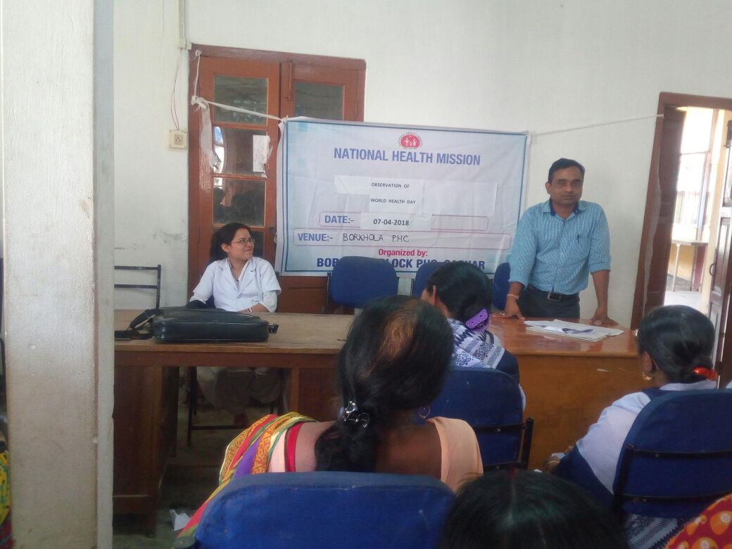

Exhibition competition at state Level under Swachata Pakhwada
An Exhibition competition was held on 8th April on Swachata theme where all the 27 Districts participated. And best district is awarded by Hon’ble Health Minister with a appreciation certificate.
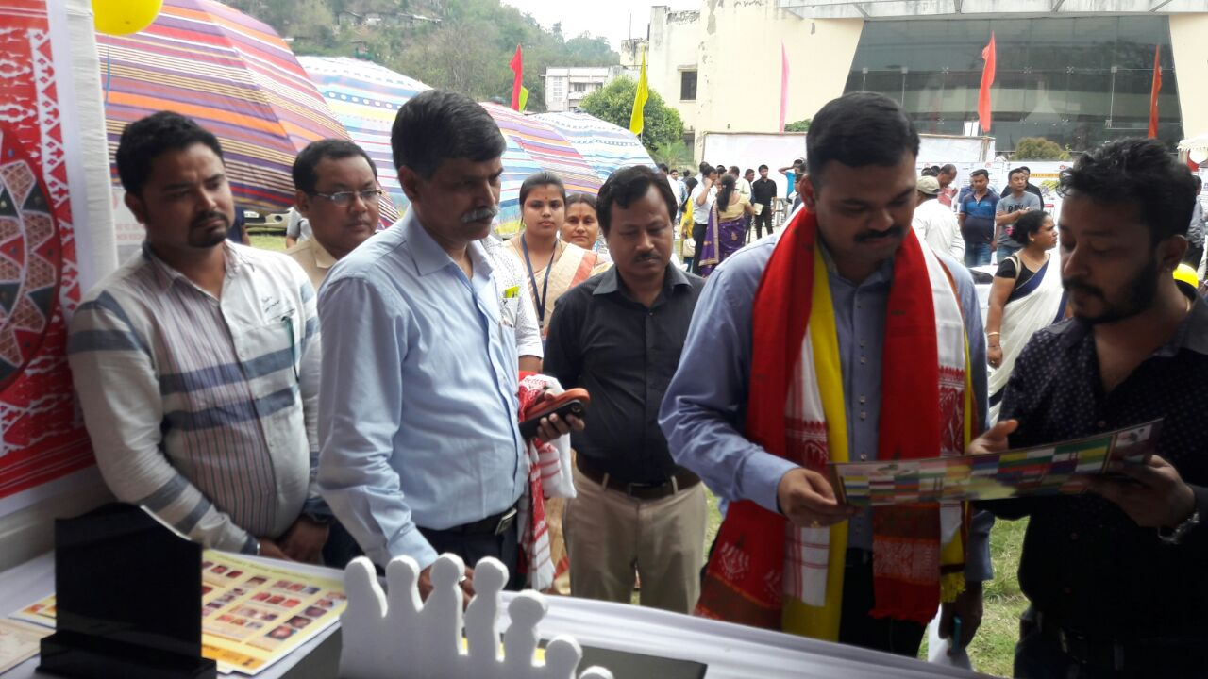
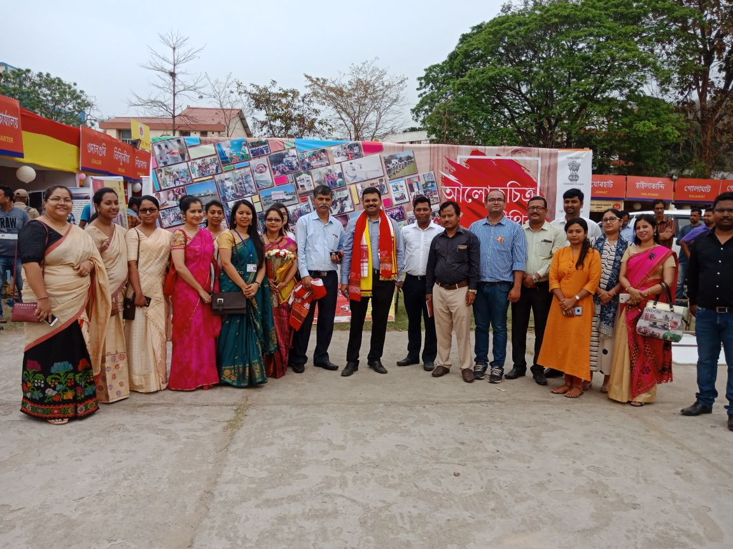

11th April to 14th April
Activities of Facility Level
- In Total 1209 Swachhata Audit has been conducted in the different Health Institution
- Different organization conducted various completion like swachh office.
- Training on cleaning of housekeeping staff were conducted at 1209 health facilities Whereas cleanliness drive on vector control were done at cent percent health facilities
- Training on cleaning of waste Management and infection control were conducted at 1209 health facilities
In total 5884 awareness drive were taken which covered in different school across Assam

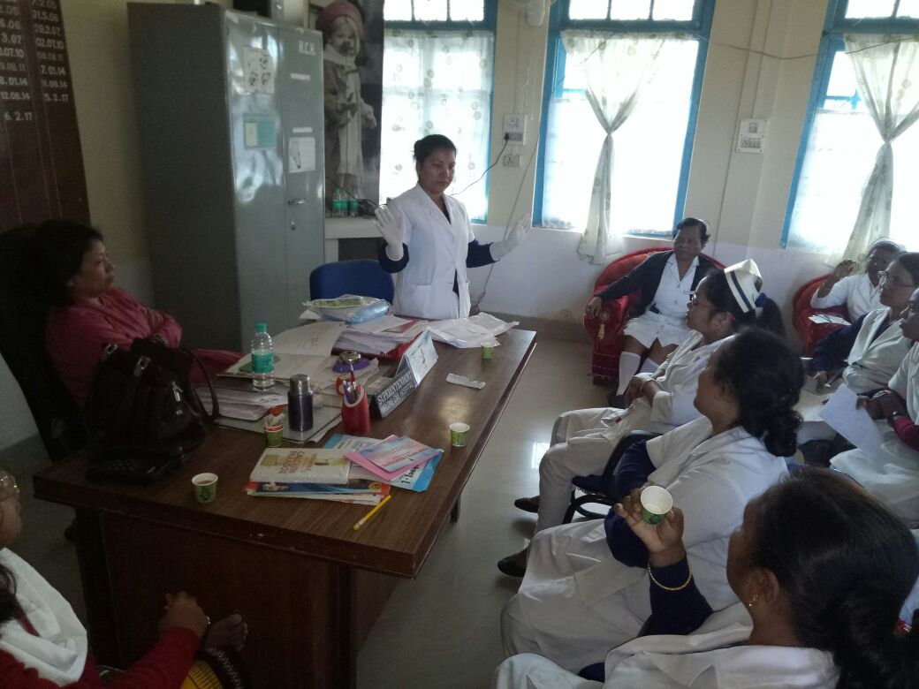

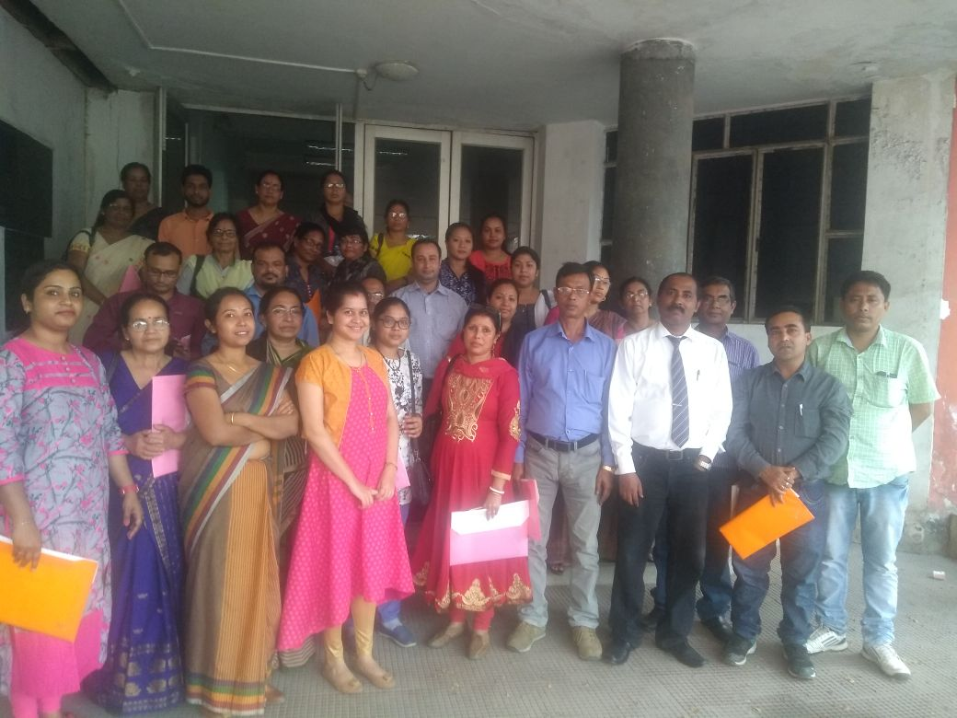

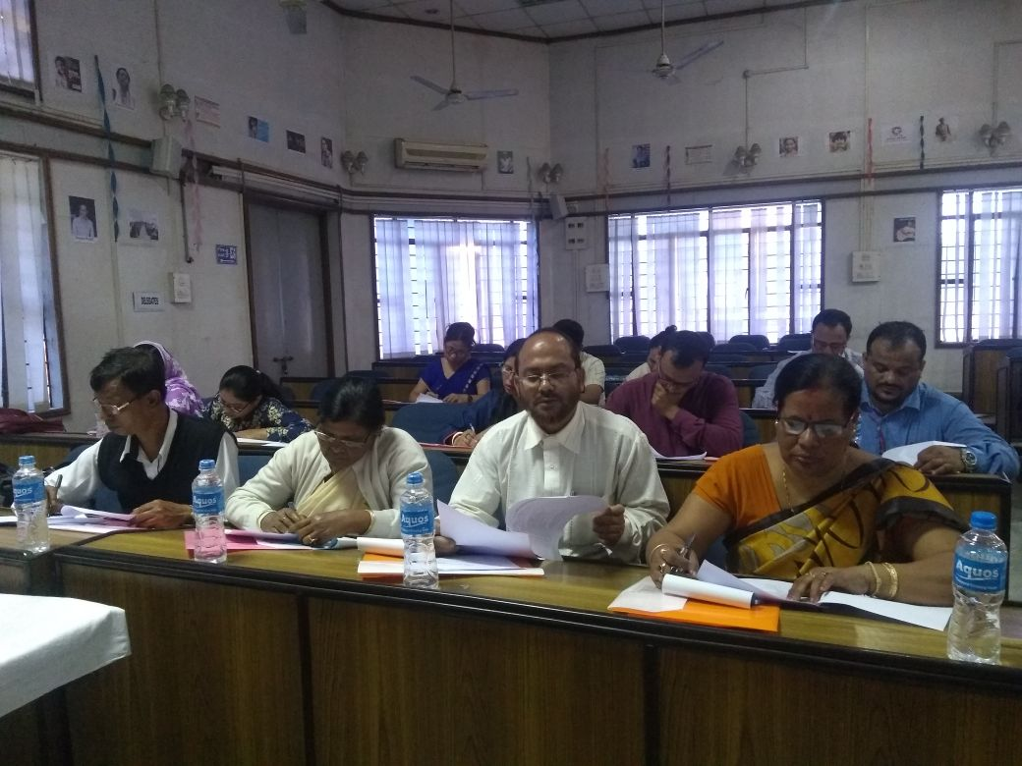

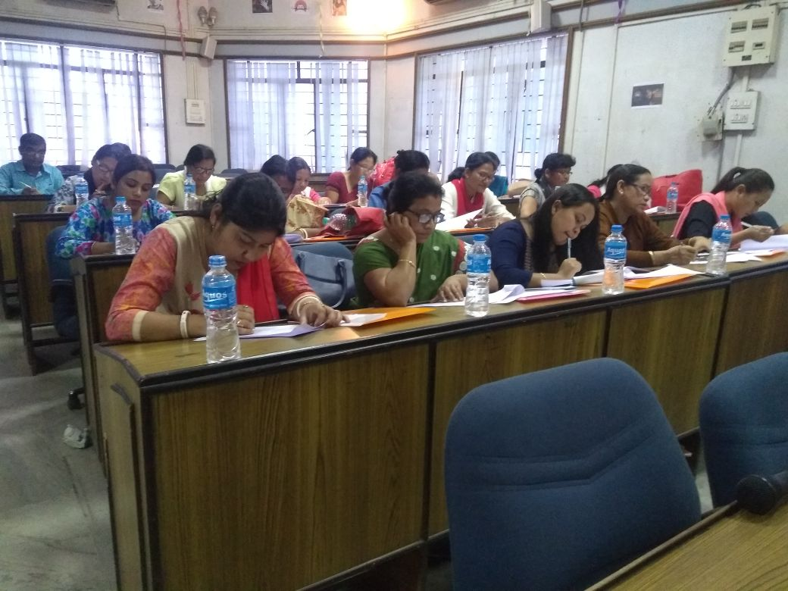

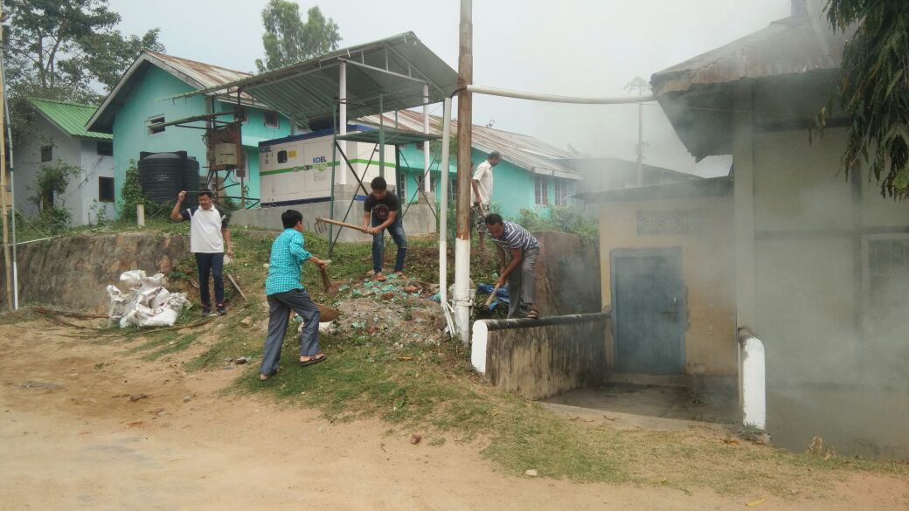

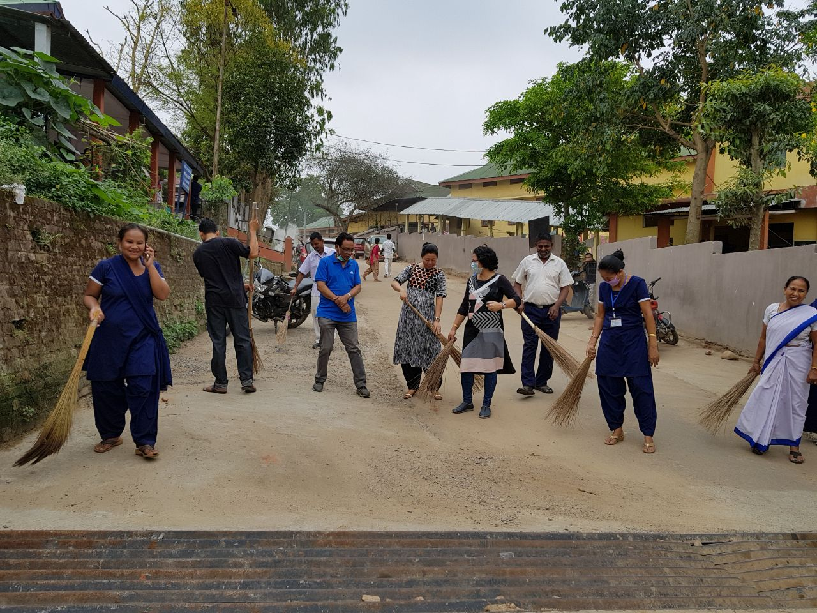
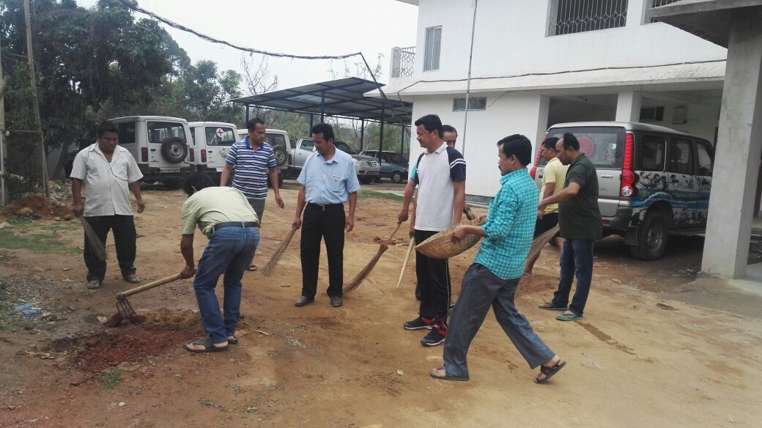

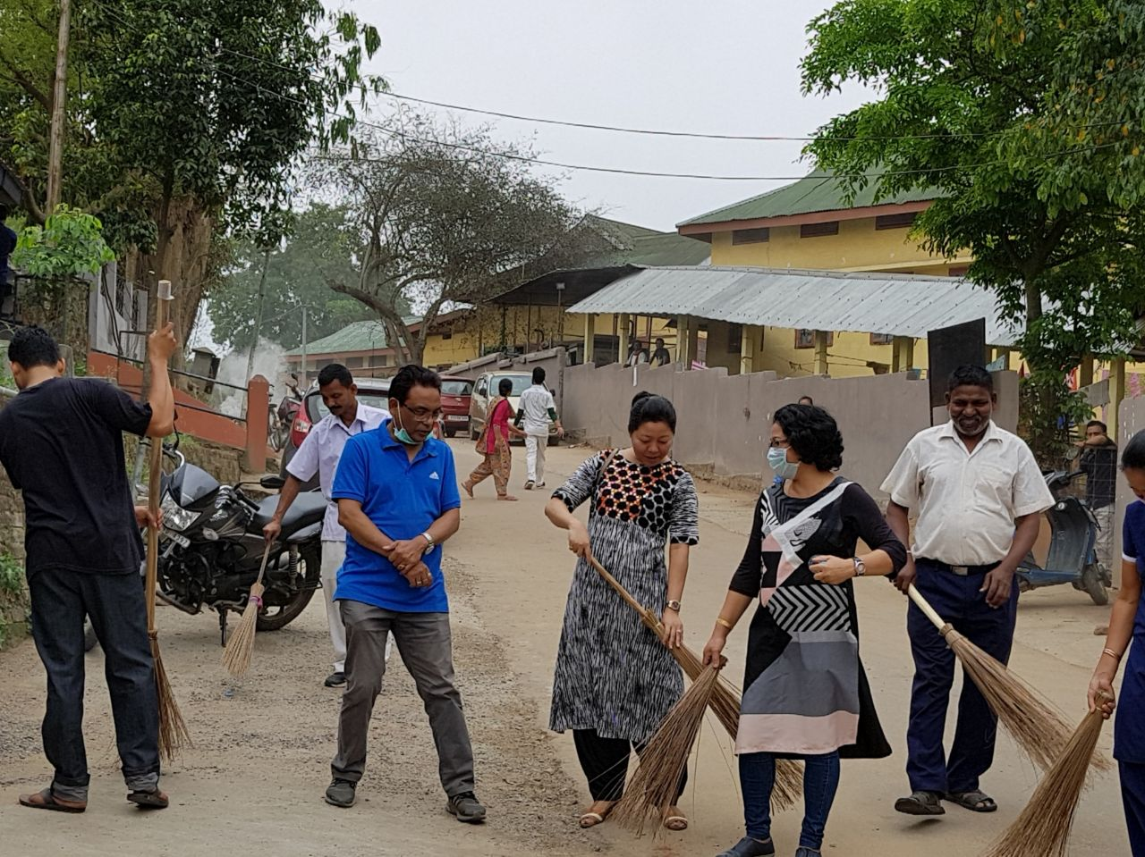

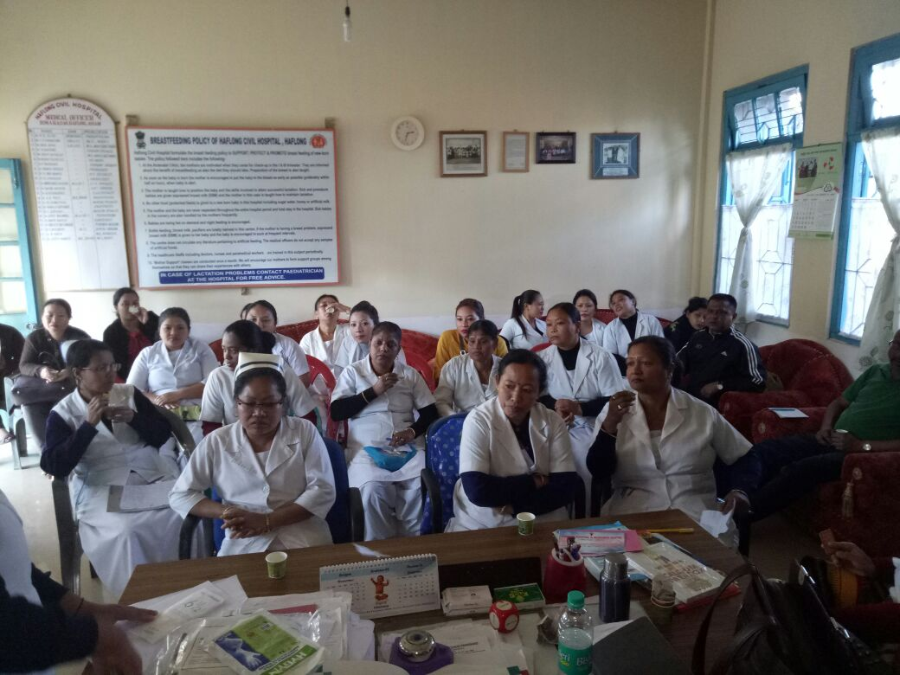

Awareness in School School
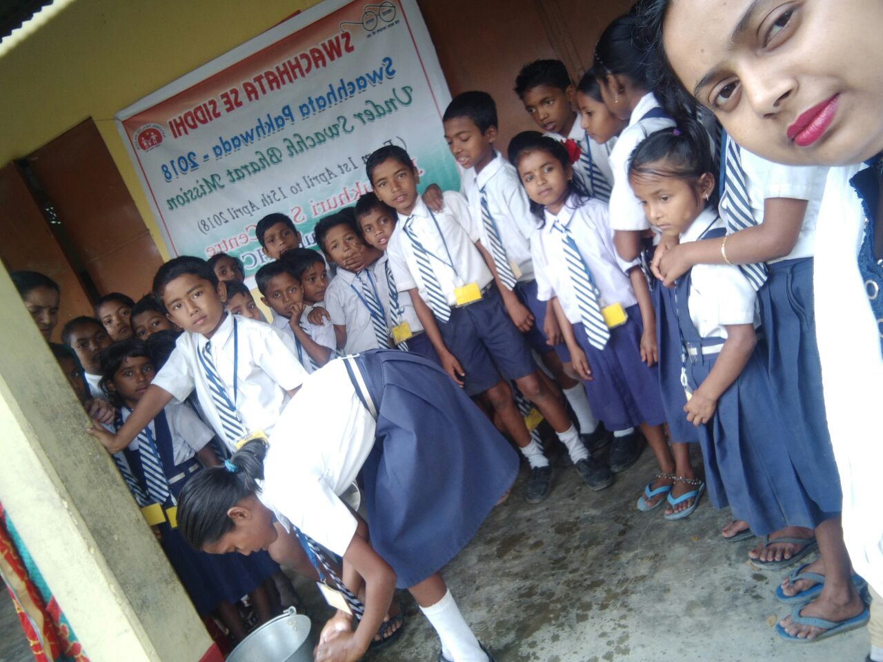

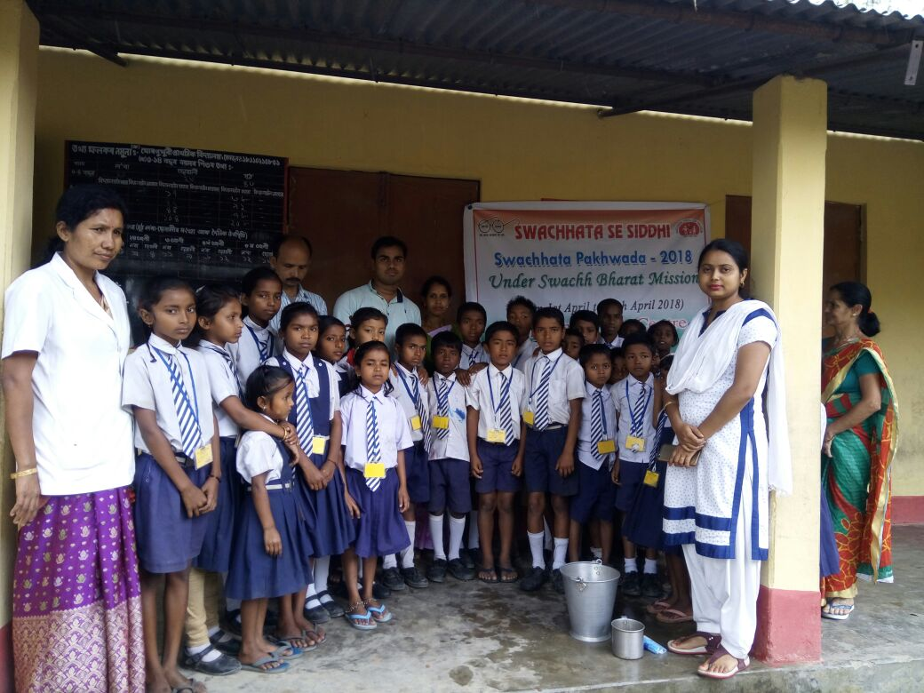

Activities of Community Level
- During the fortnight campaign 25143 numbers of VHSNC meetings were held which is 96 percent of the total meetings planned during the fortnight. Awareness camp were held on various activity like Open Defecation free village.
- In total 6884 cleanliness drive and awareness of Personal & Home Hygiene and Hand washing were taken which covered all the health facilities across Assam. Whereas the drives taken at the community were 27781 with respect to 27428 ASHA and MAS catchment areas.
- Training on Liquid and Solid waste Management and vector control were done at cent percent Community through the DCM, BCM and ASHA Supervisor. With this we would like to conclude on the progress of Swachhtapakhwadacampaign and will continue to work on the cleanliness, hygiene and infection prevention activities across health facilities in Assam

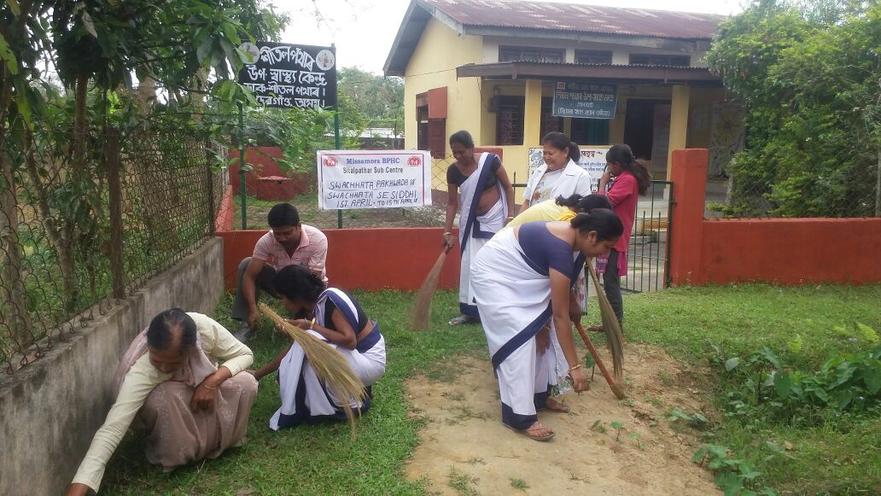

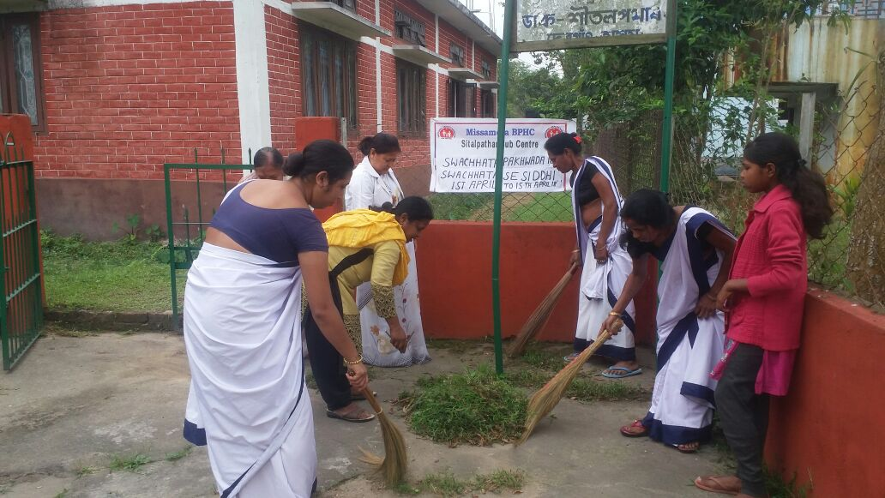

Press News

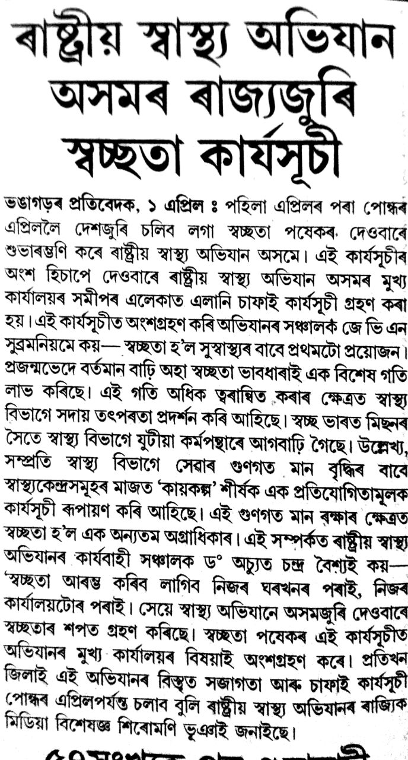
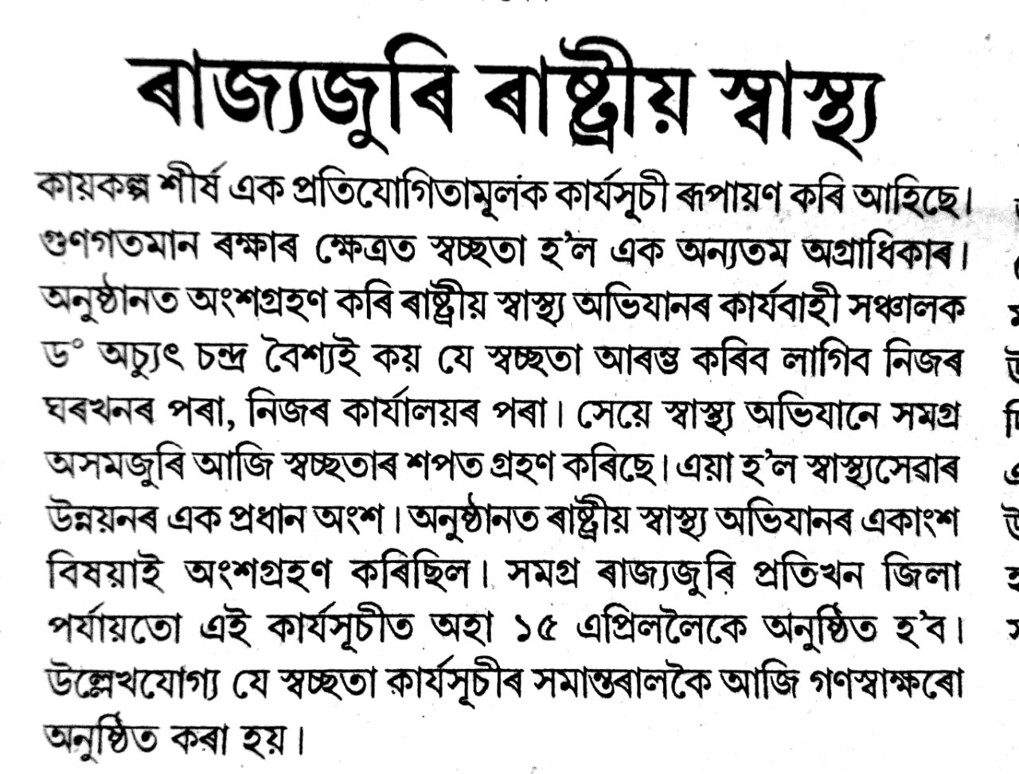

Conclusion
Swachhta Pledge
Mahatma Gandhi dreamt of an India which was not only free but also clean and developed.
Mahatma Gandhi secured freedom for Mother India.
Now it is our duty to serve Mother India by keeping the country neat and clean.
I take this pledge that I will remain committed towards cleanliness and devote time for this.
I will devote 100 hours per year, that is two hours per week, to voluntarily work for cleanliness.
I will neither litter not let others litter.
I will initiate the quest for cleanliness with myself, my family, my locality, my village and my work place.
I believe that the countries of the world that appear clean are so because their citizens don't indulge in littering nor do they allow it to happen.
With this firm belief, I will propagate the message of Swachh Bharat Mission in villages and towns.
I will encourage 100 other persons to take this pledge which I am taking today.
I will endeavour to make them devote their 100 hours for cleanliness.
I am confident that every step I take towards cleanliness will help in making my country clean.
